# How to burn the firmware to flash

1. Get the file all we need;
2. Install the install_digilent.exe;
3. Reboot the computer;
4. Cope the burn_flash folder to the sd card;
5. Insert the SD card into the module and connect to the computer through the debug port
6. Find the uart port;
7. 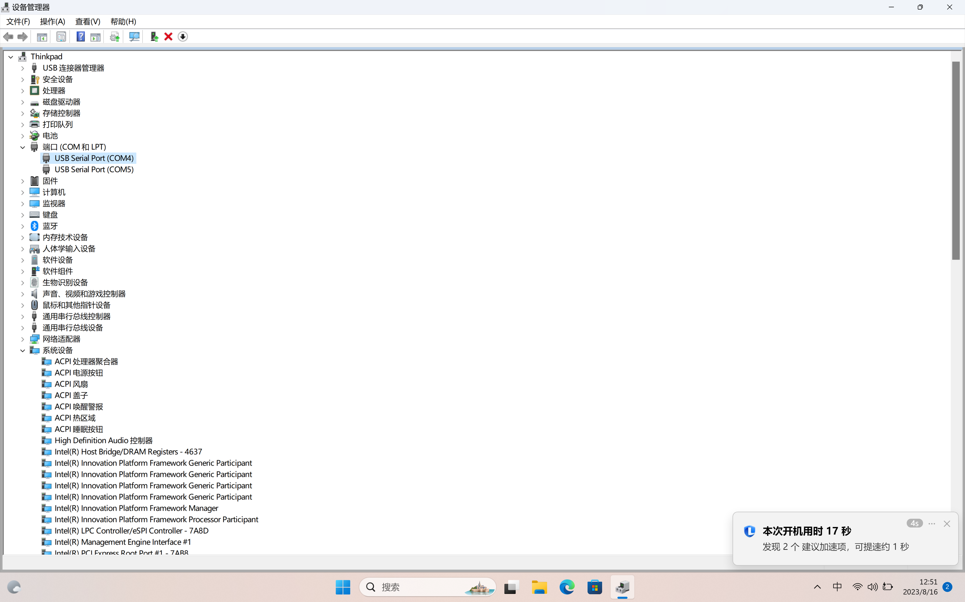
8. Use the 2ed port as an console;
9. Open the putty
10. 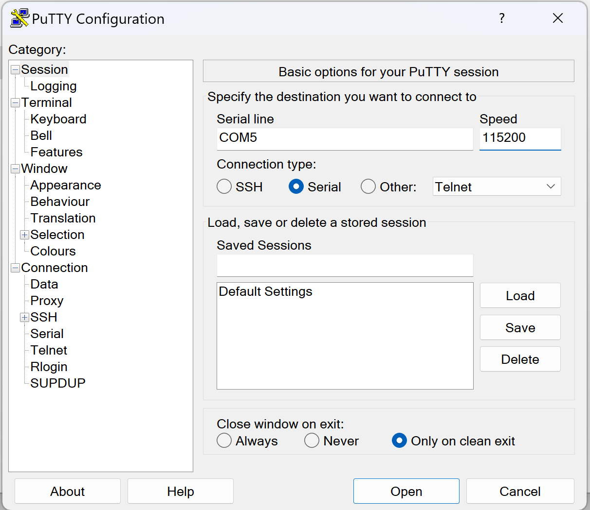
11. Click the open
12. Type the end we will get an linux console;
13. 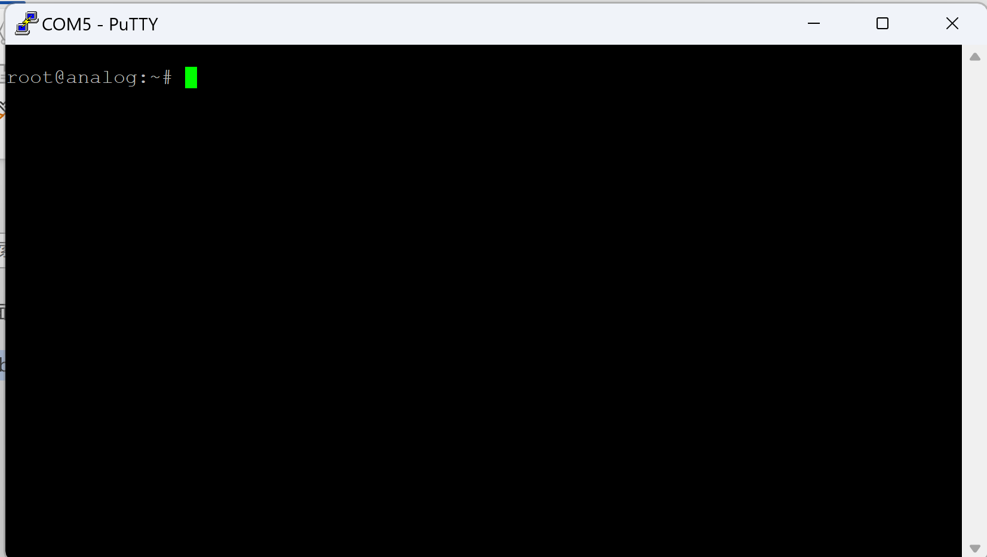
14. 电脑萤幕的截图

    描述已自动生成
15. 电脑萤幕的截图

    描述已自动生成
16. 电脑萤幕的截图

    描述已自动生成
17. Enter commands

* Reboot
* Type when the countdown
* Type sf probe
* Type sf erase 0x0 0x2000000
* Type boot
* mount /dev/mmcblk0p1 /mnt
* cd /mnt/burn_flash
* chmod +x autoconfig.sh
* ./autoconfig.sh

1. 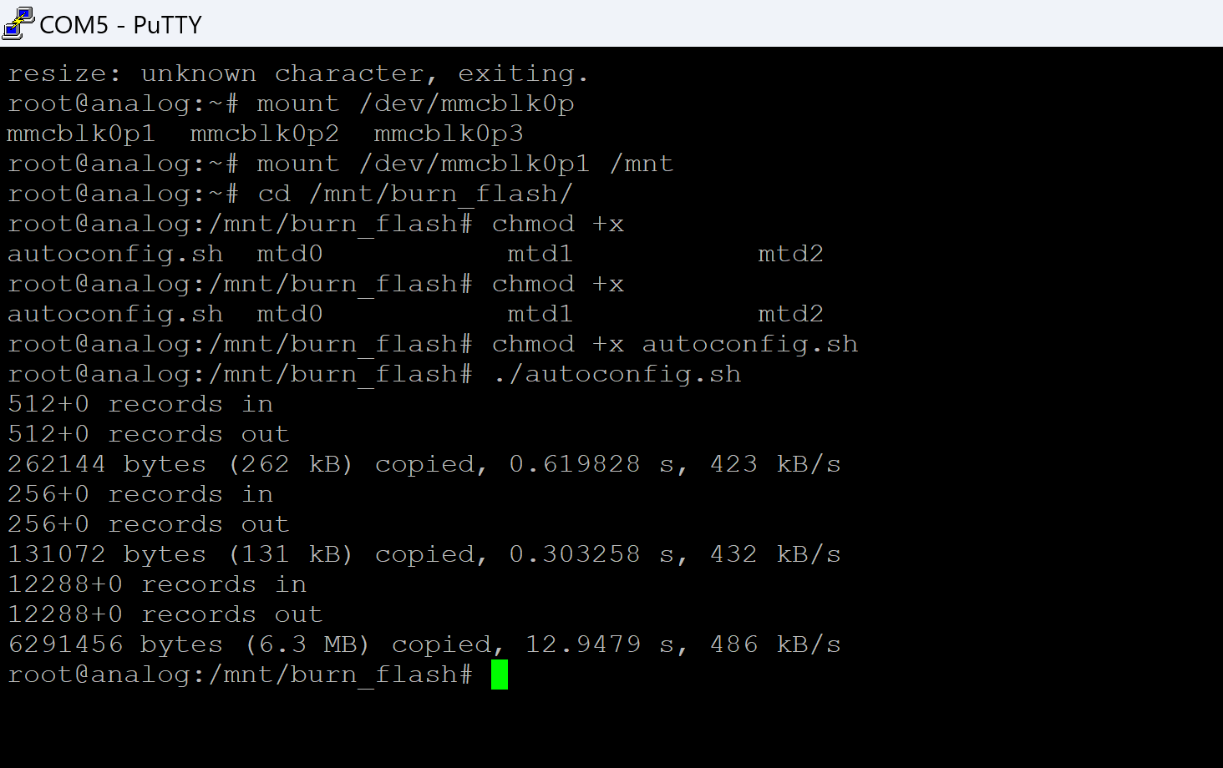
2. Wait for complete;
3. Enter the poweroff command
4. 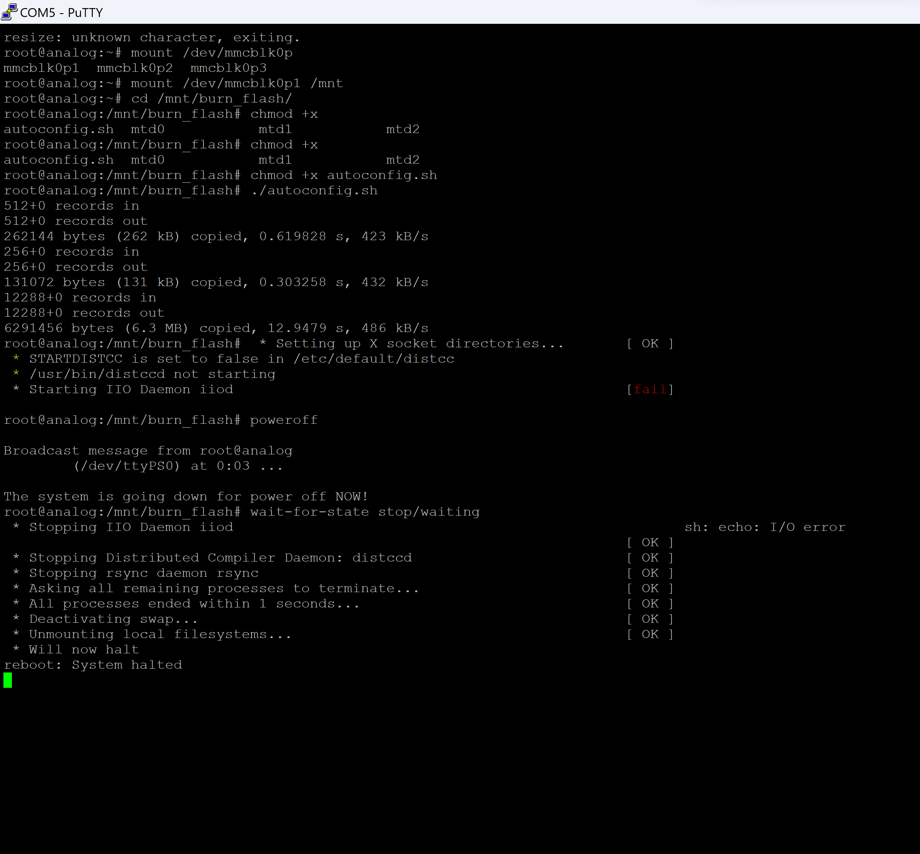
5. 
6. Congratulations, you have completed 99% of the work
7. Install the pluto driver [Windows Drivers [Analog Devices Wiki]](https://wiki.analog.com/university/tools/pluto/drivers/windows)
8. Connect the module use the otg port;
9. 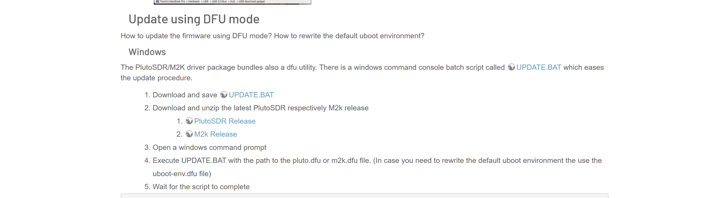
10. [Pluto/M2k Firmware Updates [Analog Devices Wiki]](https://wiki.analog.com/university/tools/pluto/users/firmware) **Update the firmware I provided with UPDATE.BAT**
11. 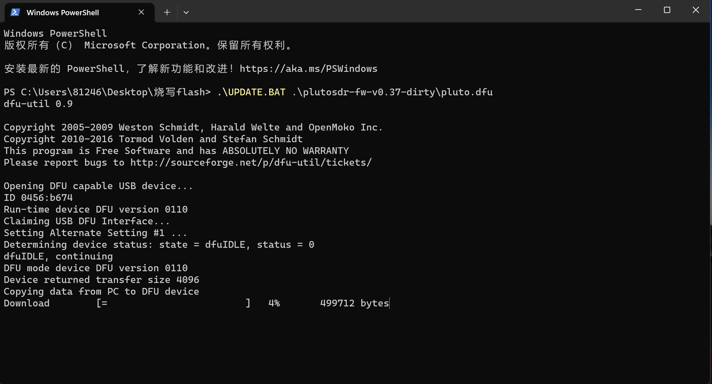
12. Wait for a moment
13. 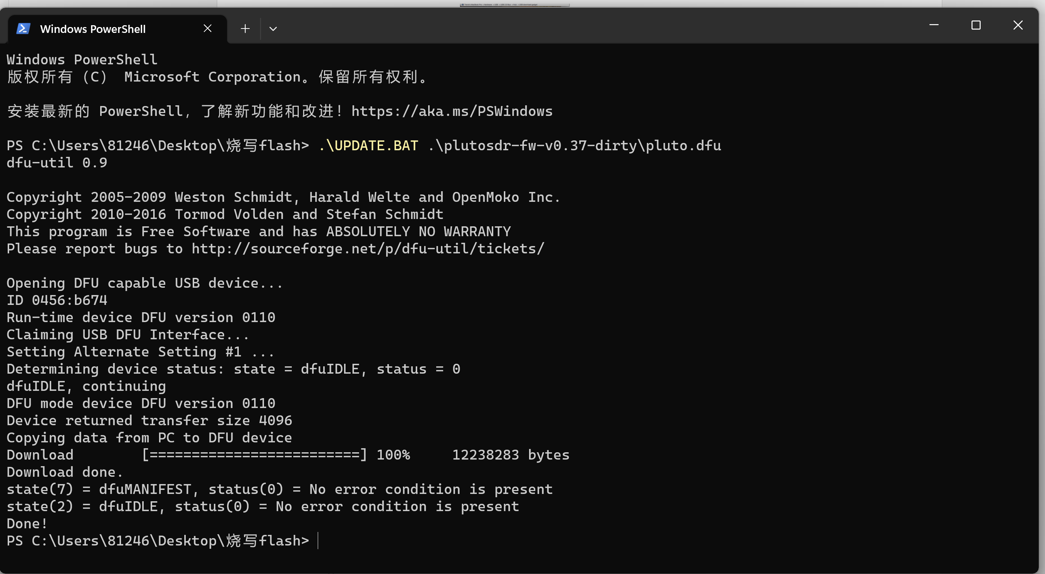
14. Reconnect the usb.
15. You will see an LED flashing;

Summary:

1. We use SD cards to burn down the basic parts

2. Using dfu to burn and write pluto firmware

Attention points:

When using dfu mode, unplug the SD card